Computer software Settings - Madrix parameters
The T-790/760 controller is connected to the computer through the network cable, and the parameters are set by the computer software
First, computer IP Settings
1. Access the network and sharing center
Right click on the network connection icon in the desktop shortcut bar and click on "Open Network and Sharing Center"
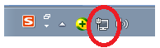
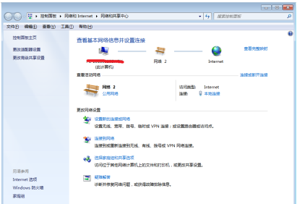

2. Go to Change adapter Settings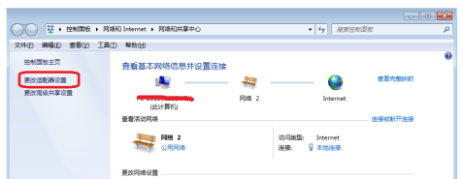

3. Click Change adapter Settings to enter "Network Connection"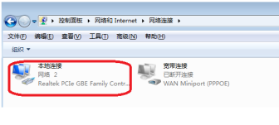
4. Right click on local connection, right-click menu "Properties"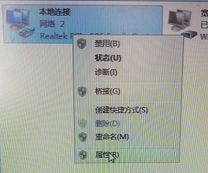
5. Click <Internet Protocol Version 4 (TCP/IPV4) >
6. Change the IP address
IP地址：192.168.60.2
子网掩码：255.255.255.0
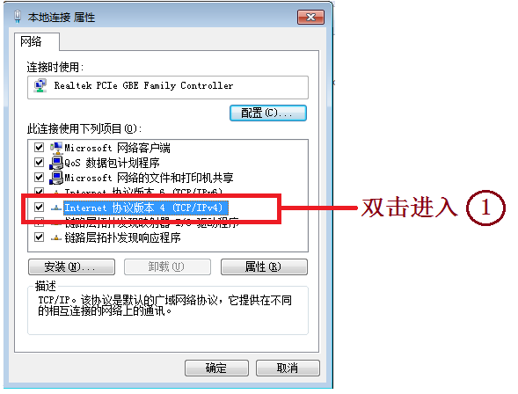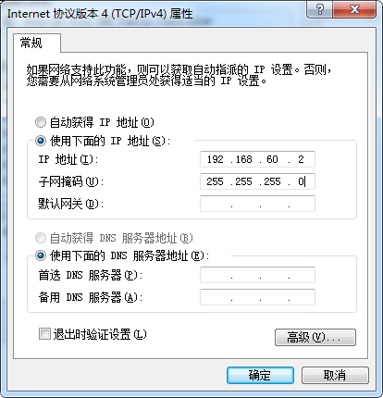
注1：电脑IP地址从192.168.60.2。
注2：T-790控制器麦爵仕模式下IP地址从192.168.60.3开始使用。
2. Software Settings -- controller parameters
There are two ways to set this item:
1. Computer software LedEdit-K/LedPlayer-K software setting (recommended)
2. Set the controller manually
1、LedEdit-k /LedPlayer-KSoftware set MADRIX parameters
1.1. Open LedEdit-k v6.2/ LedPlayer-k V6.0 or later.
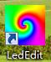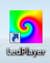
1.2. Controller Number
The controller is connected to the PC through a network cable. The controller must be numbered starting with ID0001
1.2.1. Click < Engineering Configuration >--< Online Coding >
1.2.2. Set the start number of the controller and click the online number button to start the number, as shown in Figure 3
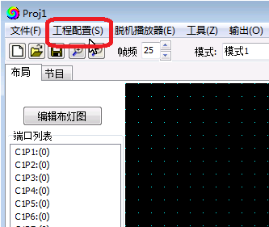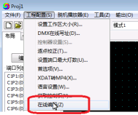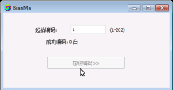
图1 图 2 图3
1.2.3. Complete the online coding and check the controller number.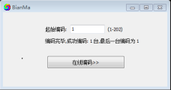
1.2.4. After the controller number is complete, set the Madrix parameters
1.3 Setting Madrix Parameters
1.3.1 Click < Project Configuration >--< Set Madrix Parameters >
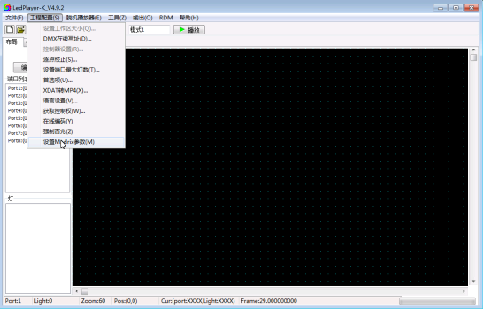
1.3.2. Go to the Parameter setting screen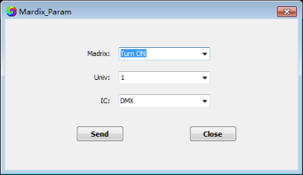

1.3.3. Parameter setting
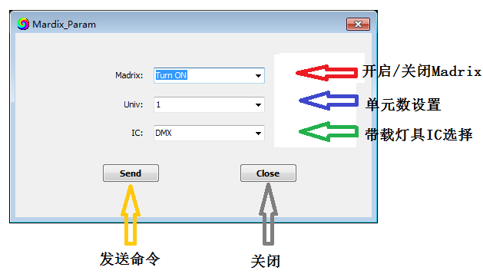

○1 Enable/Disable Maxis
The option is to click the drop-down arrow and select Turn ON /Turn OFF Maix mode. ○2 Set the number of units
Click the drop-down arrow to select 1/2/3/4/5/6 units, that is, the number of units with load light per port of the controller
Note 1: If the controller is set to carry 1 unit per port, the controller 8 port occupies 8 units;
The first controller occupies units 1-8, as shown in the following figure:
The second controller occupies units 9-16, as shown in the following figure:
And so on.
Note 2: If the controller is set to carry 2 units per port, the controller 8 port occupies 16 units; The first controller occupies 1-16, the second controller occupies 17-32, the third controller occupies 33-48, and so on.
Note 3: If the controller is set to carry 3 units per port, the controller 8 port occupies 24 units; The first controller occupies 1-24, the second controller occupies 25-48, the third controller occupies 49-72, and so on.
Note 4: The T-790 control system supports a maximum output of 2048 units with 170 pixels per unit.
IC selection with load light
Click the drop-down arrow and select DMX /UCS1903/DMX 500K/DMX 750K, that is, DMX512 chip lamps or UCCS1903 chip lamps /DMX512 chips (500K/750K rate)
. Click <SEND> to send parameters to the controller.

3.1.3 IC model with load light
Click the drop-down arrow and select DMX /1903, DMX512 chip luminaire or regular 1903 luminaire.

3.1.4 Click <SEND> to send parameters to the controller.
3. MADRIX software operation
1. Connect the computer to the controller. Controller display: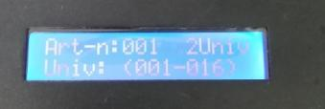
2. Install the software and insert the key (encrypted USB flash drive).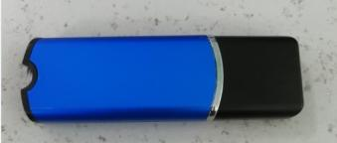
3. Open the software (the software interface is as follows)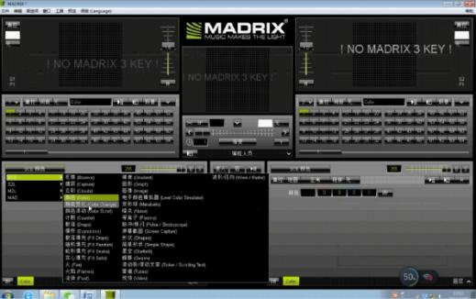
4. Click "New" in "File" to display the following picture: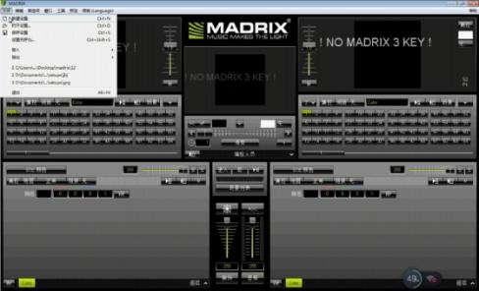
5. Device Manager (F4)
① Click on the Device Manager (F4) in "Preferences" to display the following picture:
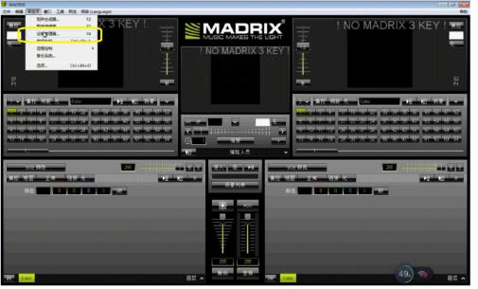
② Enter the Device Manager interface, click the "ANT-NET" option, and then click the "Search" button, the following picture will be displayed:
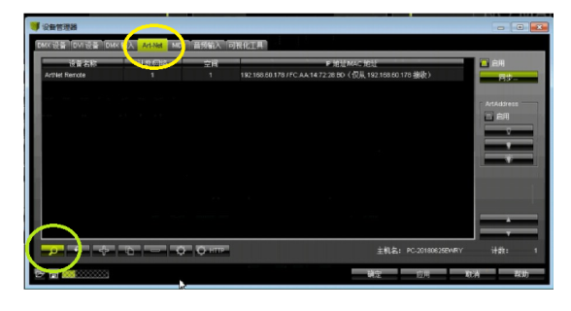
③ Complete the search to display the controller model, as shown in the picture below, and then click the "Enable - Sync" button
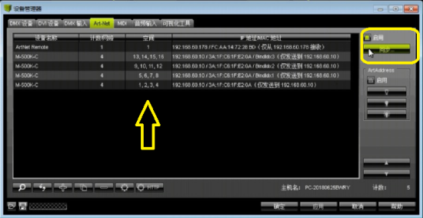
④ Synchronization mode, click the red box below, the purpose is to ask the computer to send "synchronization command", click to confirm the exit after completion.
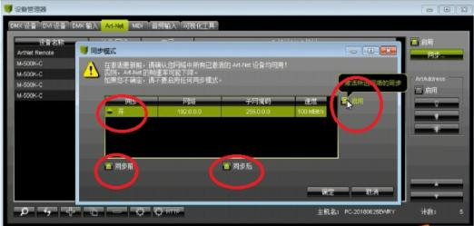
⑤ Click the DMX device button, left click one of the device bar, then CTRL+A(select all), right click, all controllers will be enabled, as shown in the picture below; When you're done, click OK
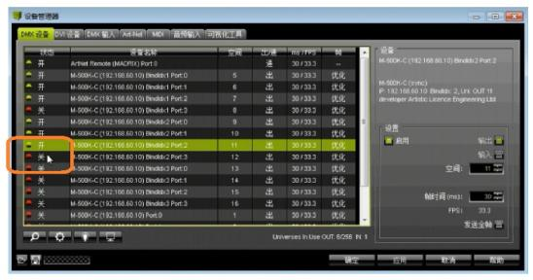
6. Adapter editor
① Click on the Connection Editor (F3) in Preferences
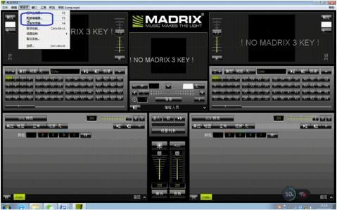
② Enter the configuration editor screen, Ctrl+A to delete the layout diagram on the page.
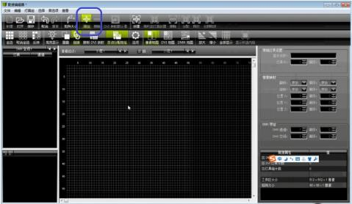
③ Click "Add" button, the "Add Lamps" page will pop up, complete the input of relevant data (lamp library lamp model, pixel distribution, connection method), click "Add", "close".
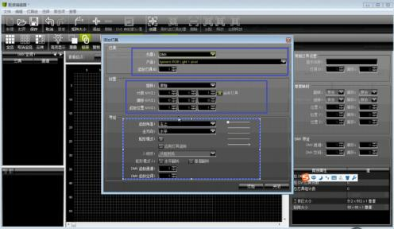
④ Click "Matrix Size", enter the matrix X, Y equivalent (display box size), click "Confirm".
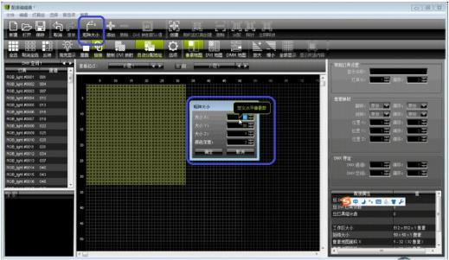
⑤ Finish the Settings, close the "Connection Editor", and return to the main screen.

7. Editing effect
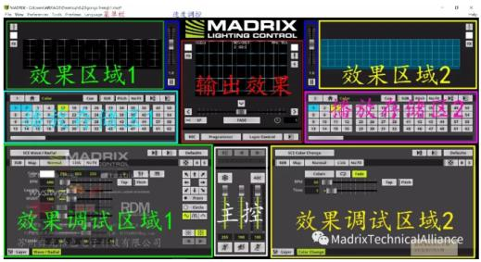

①. Software debugging area, debug the editing effect, and display in the upper side of the effect display area and output display area.
2. Effects can be stored in the playback storage area, which can store multiple effects.
3. Two debugging areas of the software can debug the editing effect respectively, and display the effect display area on the left and right sides; The two effects can also be superimposed (selected by the middle slider).
4. There are overall control buttons "Scene List", "Brightness adjustment", "Audio control" and other Settings in the main control area.
⑤. The output effect area is displayed as the final effect, as shown below:
